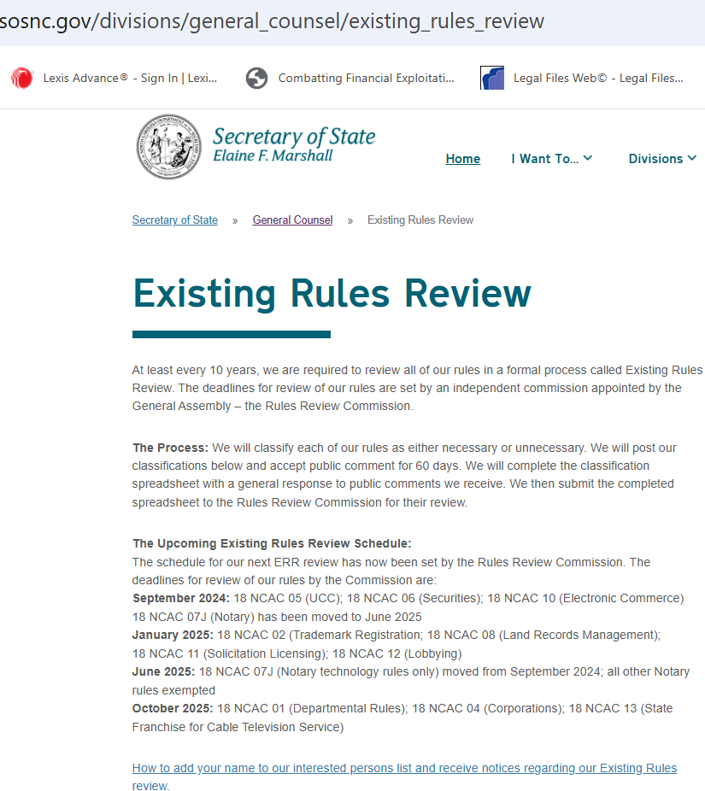

PLEASE MAKE THESE CHANGES & **PUBLISH THEM ON OR BEFORE 12/10/24.**

THANKS! AnnE

No changes to this (top) portion of web page.

Go to next 2 pages.

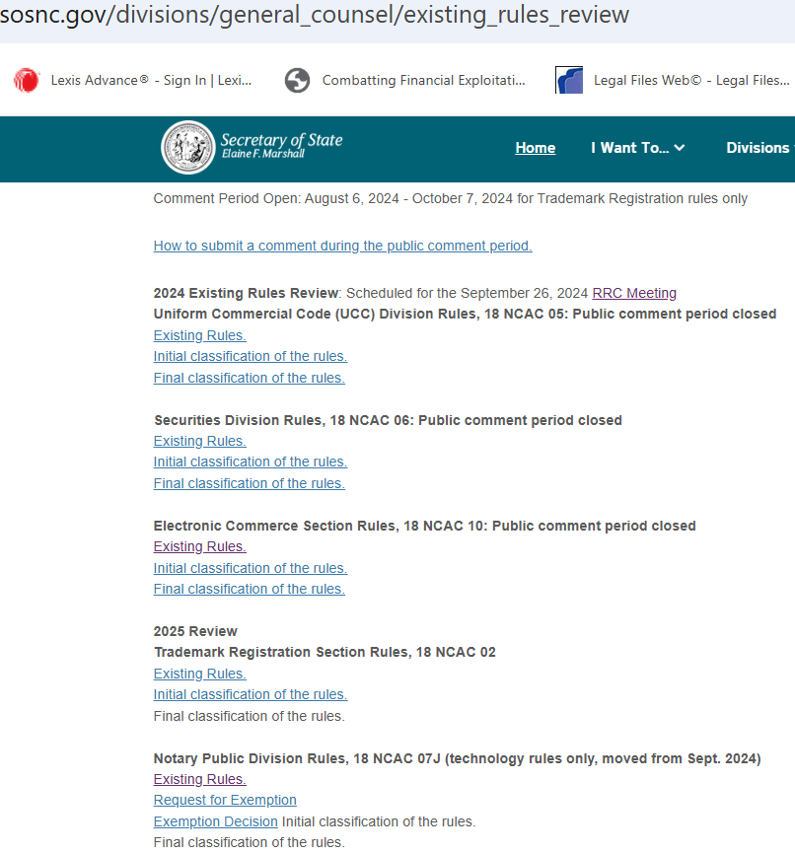

Link doc 18 NCAC 02 Final Classification & insert immediately after “Final classification of the rules”: (Scheduled for January 30, 2025 RRC Meeting)

Insert in **boldface:** Comment Periods **Closed**

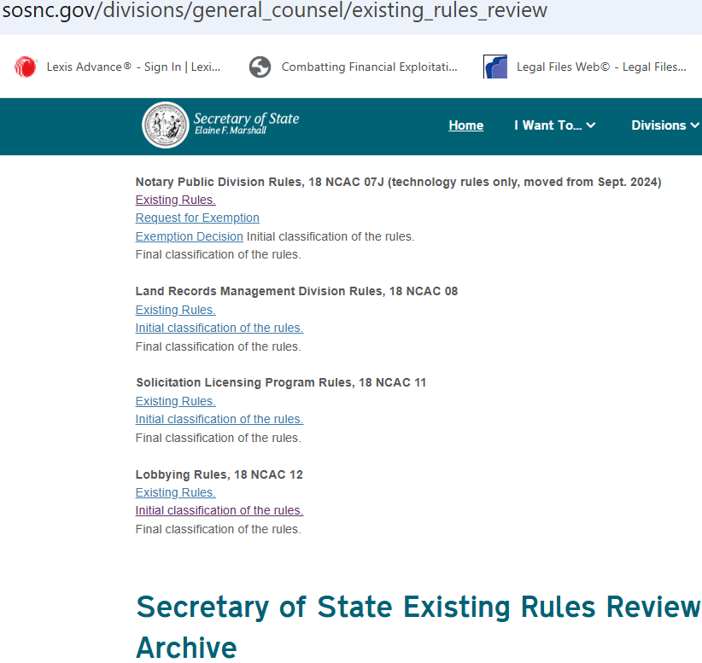

(1) Link the corresponding Final Classification (the documents are attached to this request)

&

(2) Insert the highlighted parenthetical information immediately after “Final classification of the rules.” Don’t highlight it; I’m just doing so to aid understanding of this request.

(Scheduled for January 30, 2025 RRC Meeting)