AGENDA

North Carolina Investment Adviser

Regulation Workshop

8:30 am – 3:30 pm

Presented by NC Securities Division

8:30 am – 9:00 am | Registration  Coffee and Snacks
9:00 am – 9:10 am | Welcome
9:10 am – 11:30 | Investment Adviser Fiduciary Duty and Best Practices  Presented by: Elizabeth Guido ChFC®, CLU®, CFE
11:30 – Noon | Investor Education  Presented by: John Maron
Noon – 1:00 PM | Lunch
1:00 pm – 3:00 pm | Investment Adviser Fiduciary Duty and Best Practices (continued) and Division Examination Program  Presented by: Elizabeth Guido ChFC®, CLU®, CFE

3:00 pm – 3:30 pm Question and Answer Session/Wrap-Up

Additional: Please take a minute and complete an evaluation

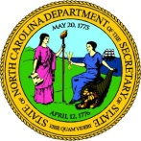
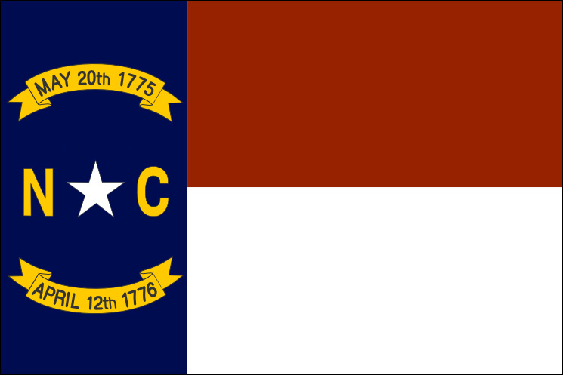North Carolina

Department of the Secretary of State
Hon. Elaine F. Marshall, Secretary Securities Division

You can contact us at:
The Securities Division
Department of the Secretary of State
PO Box 29622
Raleigh, NC 27626-0622
(919) 807-2100
For overnight mail:
The Securities Division
Department of the Secretary of State
2 South Salisbury St
Raleigh, NC 27601-2903

The Securities Hotline
(800) 688-4507
Kevin M. Harrington
Director, Securities Division and Deputy Securities Administrator
kharrington@sosnc.gov

Allan C.J. Russ
Senior Enforcement Attorney
aruss@sosnc.gov

Elizabeth Guido, ChFC®, CLU®, CFE
Senior Financial Investigator
eguido@sosnc.gov

John Maron
Director, Investor Education Program
jmaron@sosnc.gov

