INSTRUCTIONS: Please complete the information listed below in order to withdraw your health care directive information from our database. When completed, YOUR SIGNATURE MUST BE NOTARIZED BY A COMMISSIONED NOTARY.

Please return this form to the address listed above. There is NO FEE for this service.
- Registrant’s Full Name
- Registrant’s File Number:
- Check the health care directive(s) that you wish to remove from the registry.
A health care power of attorney;
Advance directive for a natural death (living will);
An advance instruction for mental health treatment; or A declaration of an anatomical gift.

I understand that neither the entry of a document into, nor the removal of a document from the registry will: 1) affect the validity of the document(s) in whole or in part; 2) relate to the accuracy of the information contained in the document(s); 3) create a presumption regarding the validity of the document(s) or the accuracy of the information contained in the document(s), or that the statutory requirements for the document(s) has/have been met.
Registrant’s Signature: __________________________
If you are submitting this Removal Form for a deceased Registrant, please complete the sections below and return this form with a certified copy of the Registrant's Death Certificate. The Death Certificate will be returned to you.

Sign your name Print your name
Mailing address:

SEAL
STATE OF _________________
COUNTY OF _______________

Signed and sworn to (or affirmed) before me this day by _______________________________

day of
, 20 .
(Printed Name of Declarant)

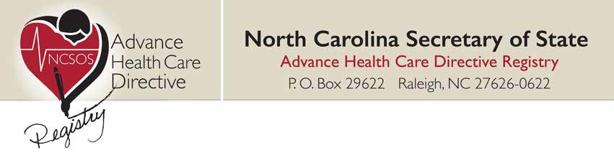
North Carolina Secretary of State
Advance Health Care Directive Registry
P.O. Box 29622 Raleigh, NC 27626-0622 www.sosnc.gov/health
REMOVAL FORM
Witness my hand and official seal, this the
(Official Signature of Notary)
, Notary
(Notary’s printed or typed name)
My commission expires:
(Date mm/dd/yyyy)

